**Report “Lab 2”**

**Anton Tserakhau**

# 2 Task “Configuring Oracle Linux Enterprise 6.1”

## 2.1 Task “Network and DNS configure”

Screenshots of ping localhost and resolving virtual machine name.

PING from **local PC(192.168.1.10)** to **VM(192.168.1.25)**

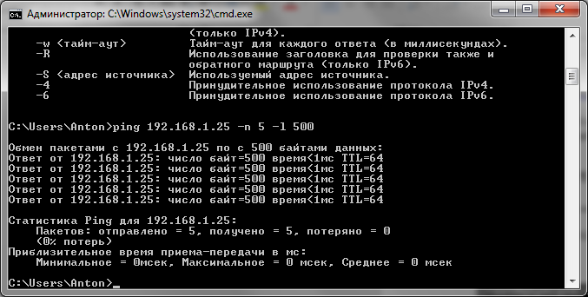

PING from **VM(192.168.1.25)** to **local PC(192.168.1.10)**

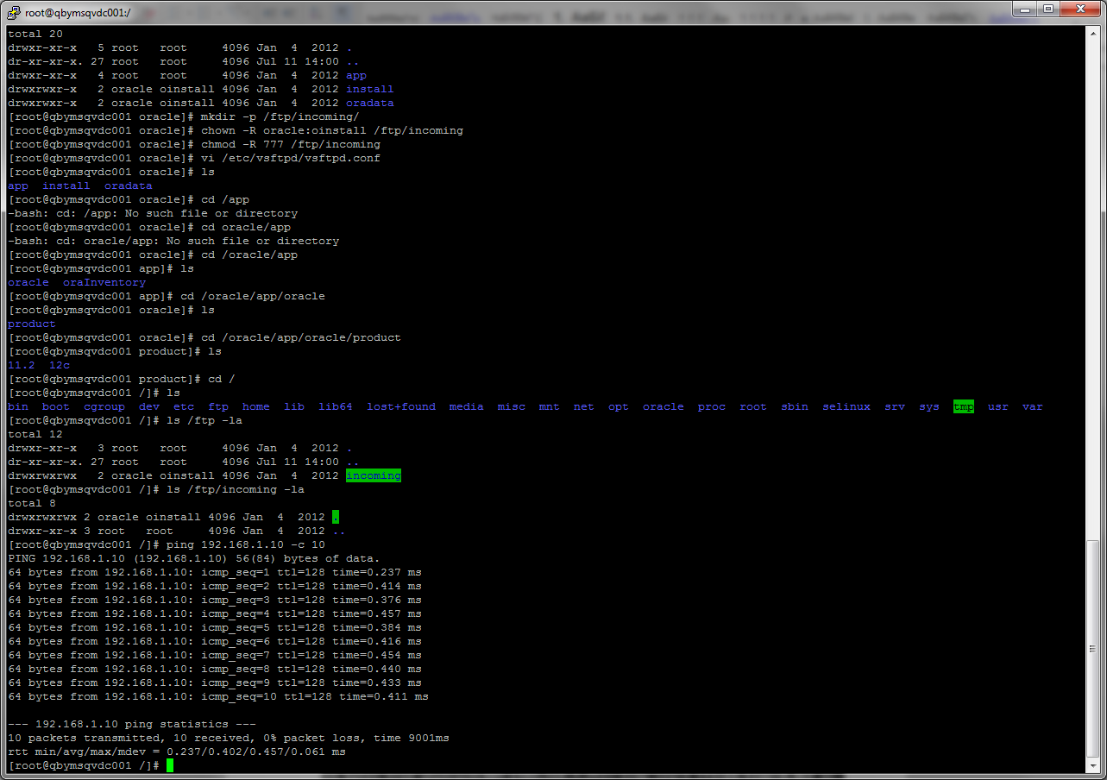

PING from **VM(192.168.1.25)** to **local PC** with using name of PC in */etc/hosts*(**local_notebook**)

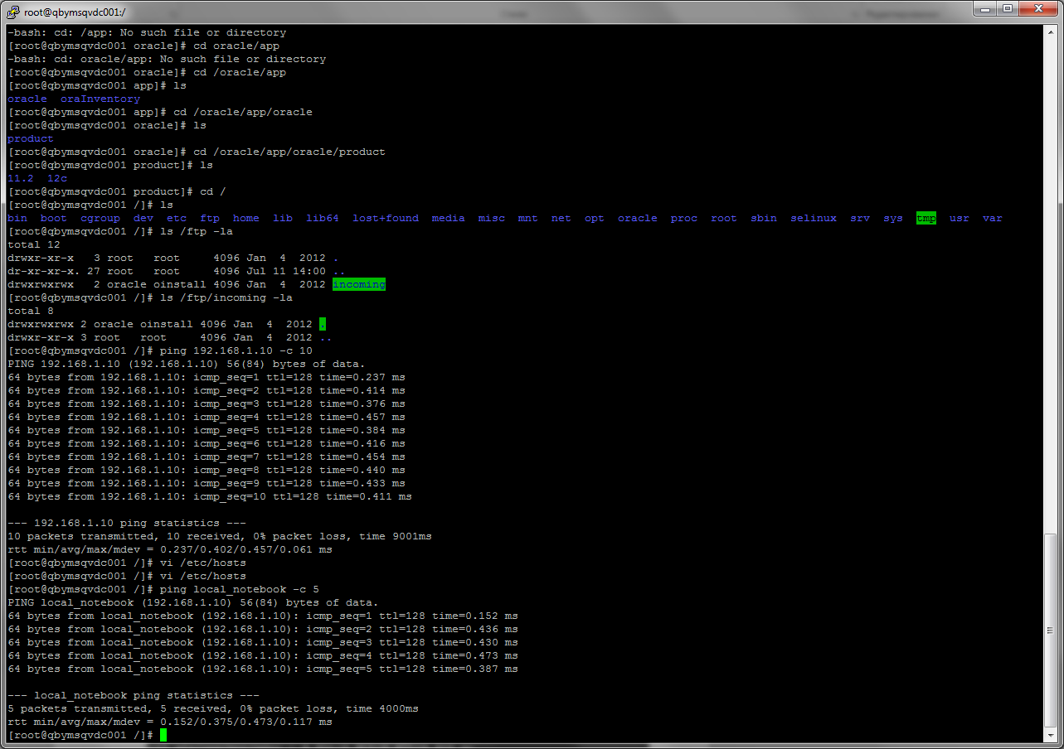

PING from **VM(192.168.1.25)** to **VM(192.168.1.25)** with using hostname(**qbymsqvdc001**)

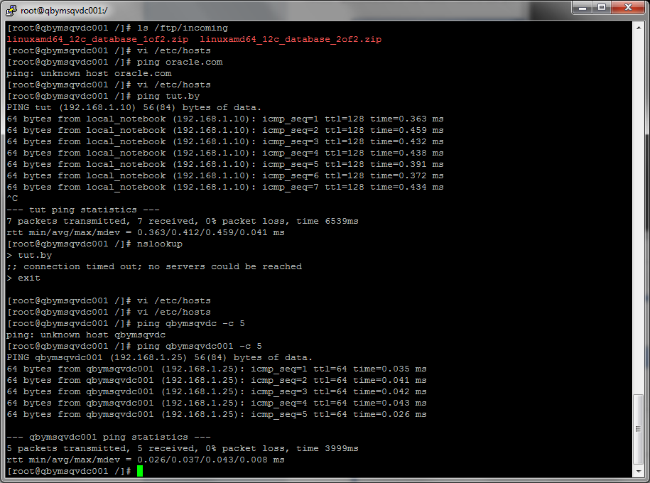

## 2.2 TASK “Configuring BASH Profile and Core Parameters”

Core parameter

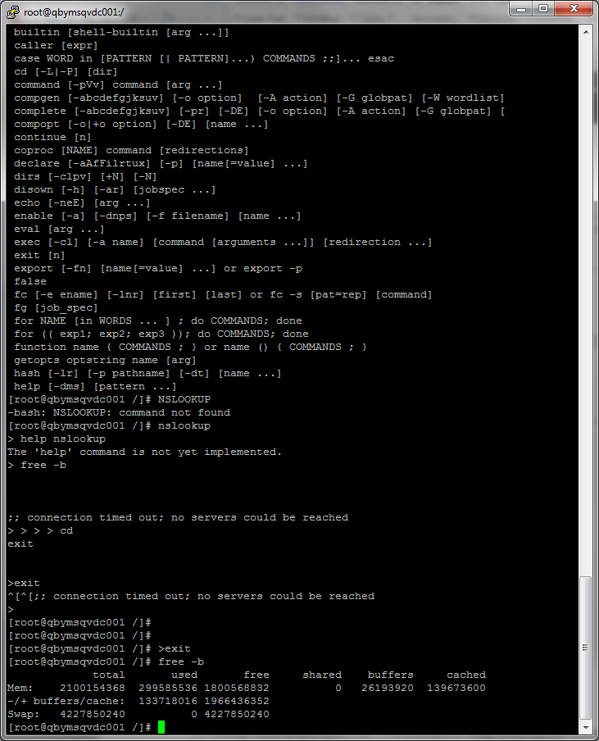

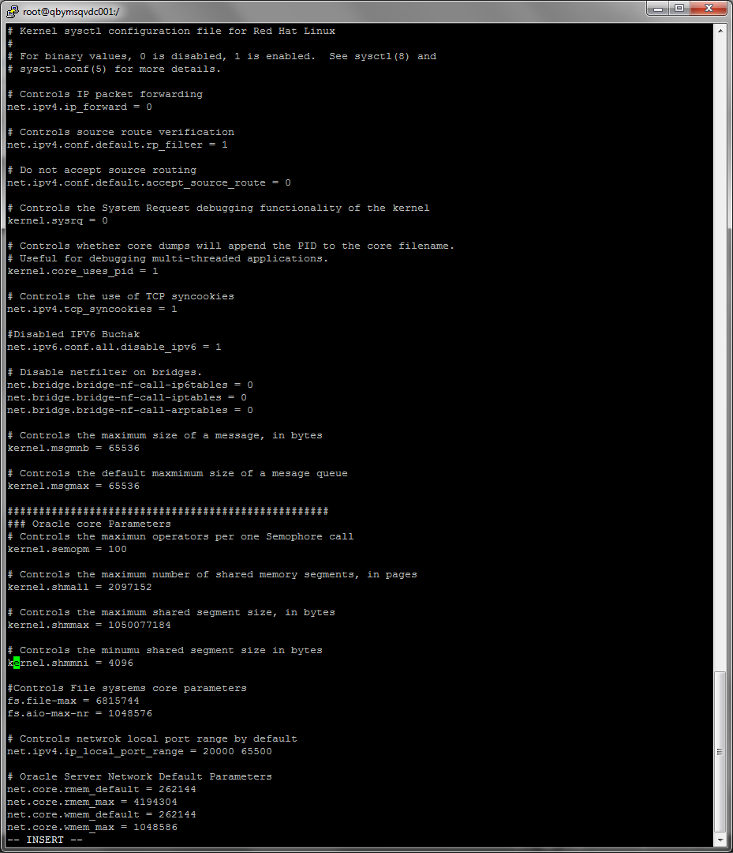

Bash Profile

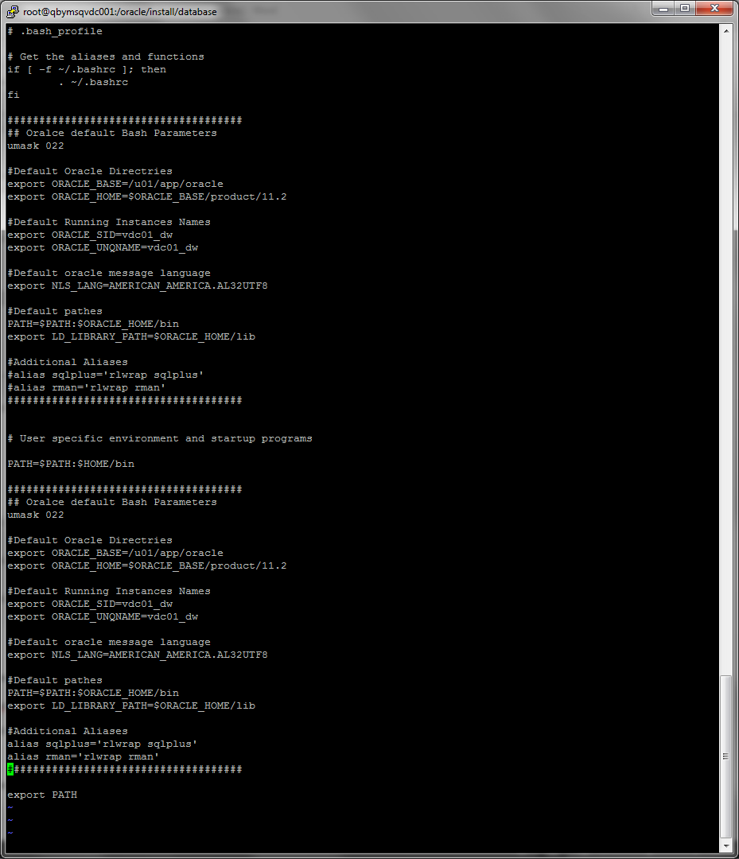

# 3 TASK “Install Oracle 11G R2”

Work with listener. Start listening.

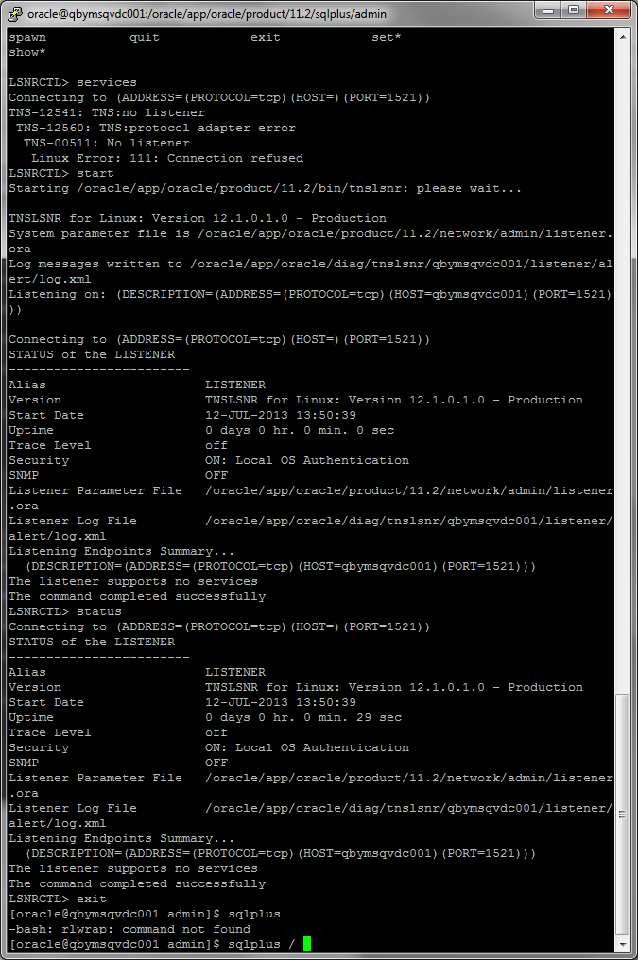

Status of listener:



Work with SQL Plus. Connect as DB admin. Run DB.

